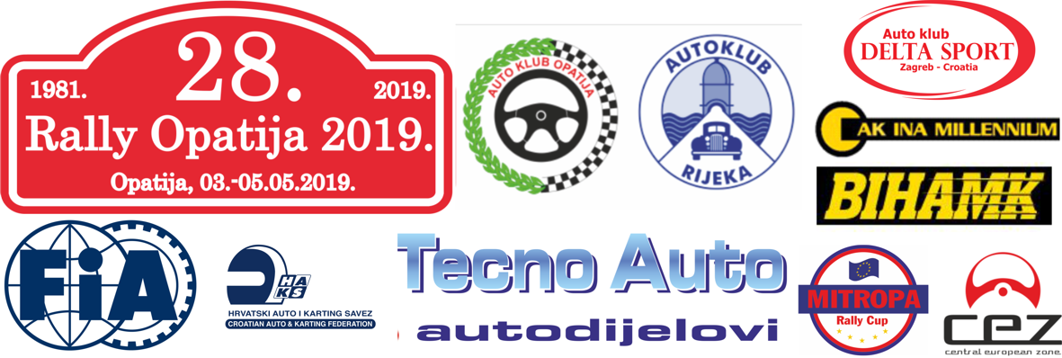

ENTRY FORM

Start number
International rally  (General classification) |  |  |  | CEZ |  | CEZ 1(GEN) |  | CEZ 2(PC) |  | CEZ 3(2WD)
MZPH |  | PH |  | 1 |  | 3 |  | 5/S3 |  | 5/S1
 |  |  |  | 2 |  | 4 |  | 5/S2 |  | 5/H
RšBIH |  | RkBIH |  | MRC |  | MRC CLUB |  | MITROPA RALLY CUP  - HISTORIC

 | ENTRANT / CLUB | 1st DRIVER / 1 CONDUTTORE | 2nd DRIVER/2 CONDUTTORE
Team name
Family name / Cognome
First name / Nome
Date of birth/Data di nascita | Junior: YES NO
Nationality / Nazionalita
Postal address / CAP
Passport n./Num.passaporto
Address for correspondence Indirizzo per la corrispondenza
Telephone (business)
Telephone (private)
Mobile
Fax
E mail
Competitions licence No. / Licenza club No.
Issuing ASN / Federazione
Driving licence No. / Licenza conduttore No.
Country of Issue/paese di emissione

DETAILS OF CAR / DETTAGLI DEL VEICOLO
Make / Marca |  | Country of registration /paese di immatricolazione
Model |  | Registration No./Targa N.
Year of manufacture / Anno di produzione |  | C.C.
Class / Classe |  | Engine No / Motore No.
Homologation No. |  | Tech. Passport No. / Passsaporto tecnicho No.
Organiser’s proposed advertising accepted (choice):  Acceto pubblicita obbligatoria del organizzatore: |  | YES | NO

ENTRY FEE
(for this entry form to be valid it must be accompanied by the appropriate entry fees, a receipt for the full amount paid to the entrants ASN, a bankers draft or details of a bank transfer etc.)
ROK | INTERNATIONAL RALLY. CEZ
Till 26 April 2018. at 24:00 hours | 300,00€
NACIONAL CHAMPIONSHIPS, MRC,MRCH / CAMPIONATI NAZIONALI, MRC, MRCH
According to art. 12 Appendix A03 ASN (CCKF), others according to national and MRC/MRCH Appendixes
/ come indicato negli allegati per campionati nazionali o MRC/MRCH

SEEDING INFORMATION / PRIORITA

Driver / Condutore: _______________________________________

Car/Auto: ________________________________________ Class: _____________________________________
FIA Priority A YES/NO Previous FIA seed YES/NO
FIA Priority B YES/NO If yes, year ________
National seed YES/NO Priority ________
National Championship winner YES/NO If yes, championship ____________________ year ________

Year/Anno |  | Event / Rally | Car / Auto | Group | O/A Position | Class Position | No. of Finishers
INT
NAT

DECLARATION OF INDEMNITY
The entrant, driver and co-driver jointly and severally acknowledge and agree the following:
- To abide by and be bound by the codes and regulations of the 28th RALLY OPATIJA 2019, held under the International Sporting Code, the Sporting and Technical Regulations of the FIA, the Regulations of the relevant National Sporting Authority (ASN) and the Supplementary Regulations issued for the 28th RALLY OPATIJA 2019.
- That motor sport is dangerous and accidents causing death, bodily damage, disability and property damage can and do happen and in consideration of the acceptance of this entry, we agree that neither the FIA, the relevant ASN, the organisers and/or promoters and their respective officers, servants, representatives and agents and any other parties shall be under any liability for our death, or any bodily injury, loss or damage which may be sustained or incurred by us as a result of participation in the 28th RALLY OPATIJA 2019, and to the fullest permitted by law agree to indemnity and hold harmless each of those parties.

I ACKNOWLEDGEMENT AND AGREEMENT
By me signature I declare that all the information contained on the entry form is correct and that I acknowledge and agree in full to the terms and conditions of the above indemnity and that I accept all the terms and conditions relating to my participation in this event.
ASN Stamp* | Signature of Entrant | Signature od First Driver | Signatere of Co-driver
* Or letter from the entrant’s ASN authorising and approving the entry

Date ___________________________________ E-mail for entries: 28rallyopatija2019@gmail.com
INFORMATION NEEDS AT TECHNICAL SERVICE RECEIPT AND IN THE PARK
The completed form must be submitted to the organizer no later than 26/04/2019
Date: |  | Note:
Responsable person of the crew: |  | Name and Surname: |  | Tel:
Others involved:

PLACE IN SERVICE PARC
 | Lenght |  | Width | Square meter - m2
Vehicle 1
Vehicle 2 (special approvall of the organizer)
Auxiliary vehicle 1
Auxiliary vehicle 2
Make a sketch! (Guaranteed maximum size is 6x6m-possible reservation of larger area with prior notice!)

